**Key Terms for Estimation of Location:**

1. Mean:
2. Weighted mean / weighted average

sum of (value times a weight) divided by sum of weights

1. Median:
2. Percentile:
3. Weighted Median:

Value such that one-half of the sum of the weights lies above and below the sorted data

1. Trimmed Mean:

Mean of all the values after dropping outliers or extreme values.

1. Robust:
2. Outlier:

**Key Terms for Estimation of Variability:**

1. **Deviations**:

Difference between observed value and estimated value

1. **Variance**:

Sum of squared deviations from the mean divided by n-1 where n is number of data values.

Also known as **Mean squared error (MSE)**

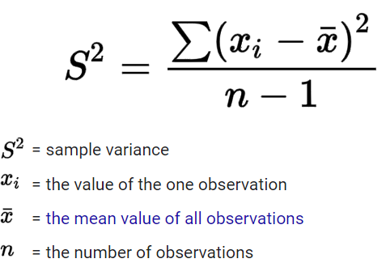

1. **Standard Deviation**:

Square root of variance

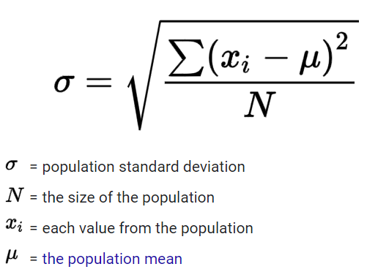

1. Mean absolute deviation: L1 norm/ Manhattan norm

Mean of absolute deviation from mean

1. Median Absolute Deviation from Median:

Median of absolute deviation from Median

1. Range:

Difference between largest and smallest value

1. Order Statistics:

Metrics based on data values sorted from smallest to largest.

1. Percentile / Quantile:
2. Interquartile Range:

Difference between 75th percentile and 25th percentile